Pre-meeting
- Agenda fine tuning is part of advisory board concept development. Please remove it as a separate service.
- Remove risk assessment, ethics review preparation, and risk mitigation strategy from services list. These are not part of an advisory board.
Meeting
- Remove simultaneous interpretation service from list. This is repetition
- To build trust with clients, content security is bare minimum, we cannot charge our clients for that. Please remove it from the list.
- Executive summary itself includes feedback from all the KOLs. Please remove KOL feedback summary report as a service. This is repetition.
- Keep only Scientific Writing and Manuscript Development. Remove Publication or Manuscript support. Both are same.
- Please check the following services. Currently, we do not have trained people to do all of this. Please remove all the selected ones.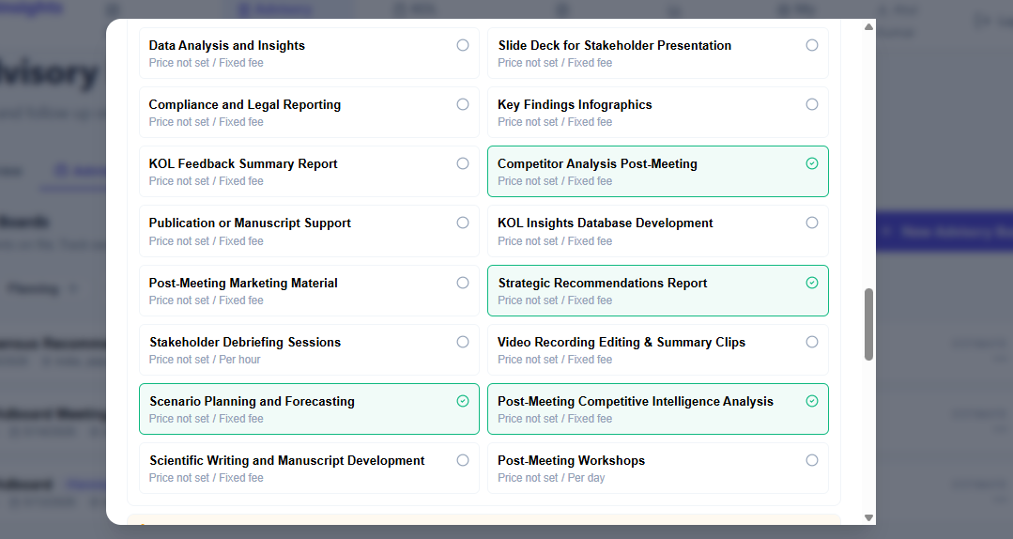
- How are we planning to provide these services? All of this comes under competitive intelligence analysis. Please remove all the selected ones.
